About: Authentic Chinese (Sichuanese) noodles and dumplings.

1425 NW Monroe Ave, Corvallis, OR.

[m.me/tianfunoodle](https://m.me/tianfunoodle?fbclid=IwAR0St18X5pt3dPpHCqv3LNYaqehlFASdSXBVG0Ui3cgp-U0uuqQ7Vk2Ss_8) (541) 757-9690

Open:

|  |  |
| --- | --- |
| Fri | 11:00–14:30 |
| Sat | 休館 |
| Sun | 11:00–14:30, 16:30–20:00 |
| Mon | 11:00–14:30, 16:30–20:00 |
| Tue | 11:00–14:30, 16:30–20:00 |
| Wed | 11:00–14:30, 16:30–20:00 |
| Thru | 11:00–14:30, 16:30–20:00 |

Beef stew noodle(spicy) – $9.5

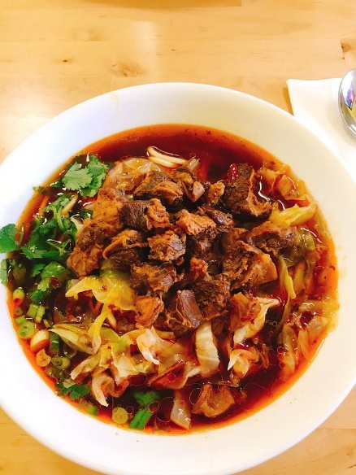

Beef stew with gluten-free noodle(spicy) - $10.0

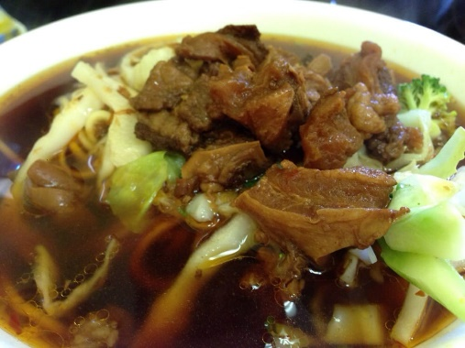

Braised Pork noodle soup - $9.0

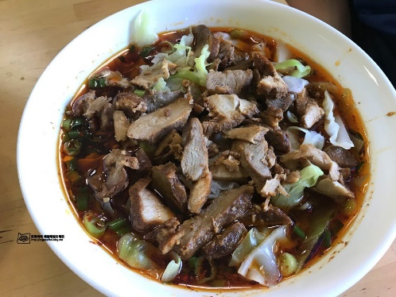

Braised Pork gluten-free noodle soup - $10.0

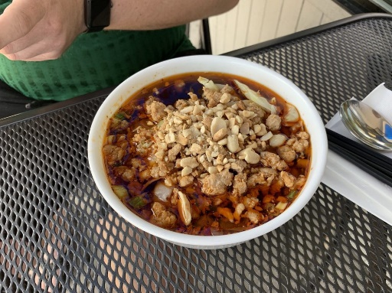

Dan Dan noodle(spicy) - $8.5

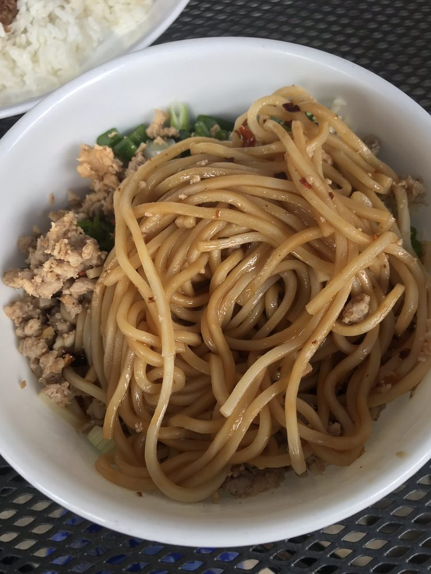

Shiitake mushroom chicken noodle soup - $8.5

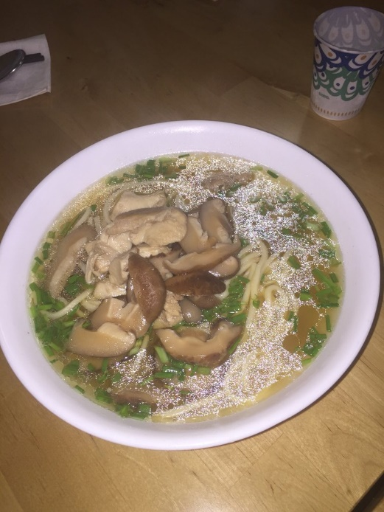

Shiitake mushroom chicken gluten-free noodle - $9.5

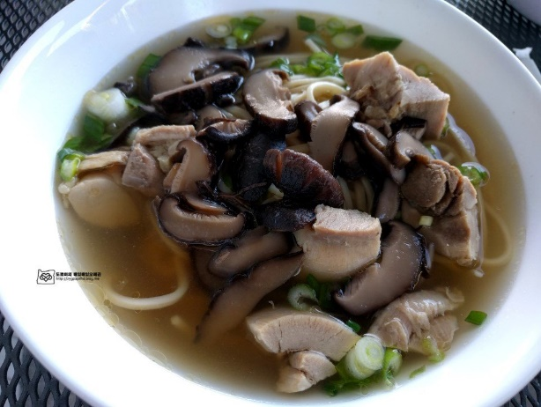

Cold noodle with chicken(spicy) – $8.5

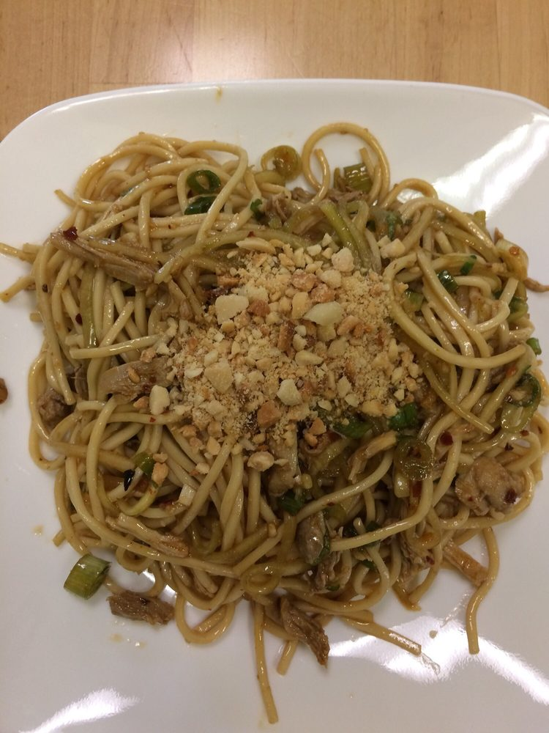

Tian Fu noodle(spicy) - $9.0

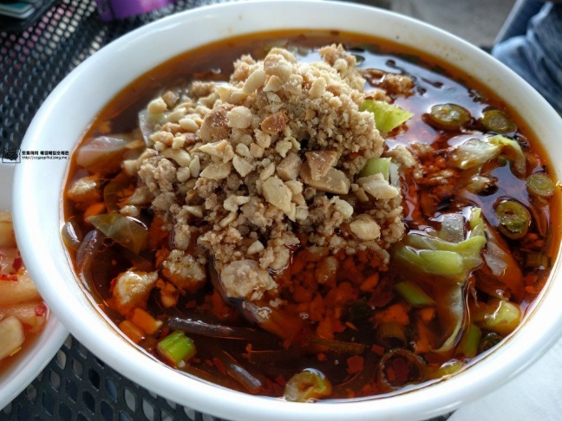

Hand-Made Dumpling - $9.5

